**CSSS Newsletter February 2015**

**PRESIDENT’S MESSAGE**

**Submitted by Barbara Cade-Menun**

“*The history of every Nation is eventually written in the way in which it cares for its soil. The United States, as evidenced by the progressive public opinion and vigorous demand which resulted in the enactment of this law, is now emerging from its youthful stage of heedless exploitation and is beginning to realize the supreme importance of treating the soil well.*”

Franklin D. Roosevelt: "Statement on Signing the Soil Conservation and Domestic Allotment Act," March 1, 1936. Online by Gerhard Peters and John T. Woolley. *The American Presidency Project*. <http://www.presidency.ucsb.edu/ws/?pid=15254>.

“*The multiple roles of soils often go unnoticed. Soils don’t have a voice, and few people speak out for them. They are our silent ally in food production*." José Graziano da Silva, United Nations Food and Agriculture Organization (UN-FAO) Director-General; http://www.fao.org/soils-2015/en/

The first quote is from Franklin D. Roosevelt, the 32nd President of the USA. He wrote these words to mark the signing of the Soil Conservation and Domestic Allotment Act. The first objective of this Act was the “*conservation of the soil itself through wise and proper land use*”. This Act was a response to the Dust Bowl in the Great Plains of the USA and Canada, whereby a combination of extreme drought and inappropriate farming practices produced wind erosion and severe dust storms. In Canada, the Prairie Farm Rehabilitation Administration (PFRA) was established in 1935 for the same reason. Sadly, R.B. Bennett does not seem to have issued any soil-themed quotes to mark the occasion.

The second quote marks a modern and equally important moment in history: the declaration by the 68th UN General Assembly designating 2015 the International Year of Soils (IYS) ([A/RES/68/232](http://www.un.org/en/ga/search/view_doc.asp?symbol=A/RES/68/232&Lang=E)). The IYS 2015 aims to increase awareness and understanding of the importance of soil for food security and essential ecosystem functions. Specific objectives:

* Raise full awareness among civil society and decision makers about the profound importance of soil for human life;
* Educate the public about the crucial role soil plays in food security, climate change adaptation and mitigation, essential ecosystem services, poverty alleviation and sustainable development;
* Support effective policies and actions for the sustainable management and protection of soil resources;
* Promote investment in sustainable soil management activities to develop and maintain healthy soils for different land users and population groups;
* Strengthen initiatives in connection with the SDG process (Sustainable Development Goals) and Post-2015 agenda;
* Advocate for rapid capacity enhancement for soil information collection and monitoring at all levels (global, regional and national).

This is a once-in-a-lifetime opportunity for all CSSS members to celebrate our scientific discipline and promote our work. Information about some of the activities planned across Canada this year is included elsewhere in the newsletter, and will be posted on the CSSS website. Let’s all help to achieve the IYS 2015 objectives. Yay Soil!

Sincerely,

Barbara Cade-Menun

President, CSSS

**NEW MEMBERS ON THE CSSS COUNCIL**

**Submitted by Bobbi Helgason and Nathan Basiliko**

On CSSS Council, Dr. Barbara Cade-Menun has moved from President Elect to President, while Dr. David Burton is now serving as Past President. As well, there are four new members this year (full bios can be found on the CSSS website):

|  |  |
| --- | --- |
| C:\Users\Nate\AppData\Local\Microsoft\Windows Live Mail\WLMDSS.tmp\WLM29C5.tmp\Maja_8424375908.jpg | *Dr. Maja Krzic, President Elect* Maja is an associate professor at the University of British Columbia, Vancouver. Her current research focuses on development of soil quality indicators for assessing management impacts on grassland and agriculture. For more than one decade, Maja has been instrumental in developing innovative tools and resources for soil educators and students at all levels and has won numerous national and international awards this work. Maja joined the CSSS in 1992 and has served as the Western Councillor, organized five sessions focused on soil science education at the CSSS annual meetings, and initiated a new CSSS Soil Education Committee in 2014. |
| Francis Zvomuya | *Francis Zvomuya, CJSS Editor-in-Chief*Francis is an associate professor in the Department of Soil Science at the University of Manitoba. He has a Ph.D. in Soil Science from the University of Minnesota, a M.Sc. from the University of Reading (England), and a B.Sc. from the University of Zimbabwe. His recent work has included remediation of metal-contaminated soils, wetland-based and terrestrial phytoremediation of end-of-life municipal lagoons, beneficial utilization of agricultural and industrial byproducts, and land spreading of drilling waste. |
| C:\Users\Nate\AppData\Local\Microsoft\Windows Live Mail\WLMDSS.tmp\WLM8D98.tmp\CarolynWilson.jpg | *Carolyn Wilson, Student Representative*  Carolyn is currently a M.Sc. student with Dr. David Burton in the Department of Environmental Sciences and with Dr. Bernie Zebarth at Agriculture and Agri-Food Canada. She is interested in soil quality and, in particular, studying the potential benefits of compost application in potato production. Carolyn graduated with a B.Sc. (Honours) in Biology-Chemistry and a B.Ed. from the University of New Brunswick. She is currently the co-chair of the Dalhousie Agrology Club and is working with the Nova Scotia Department of Agriculture to improve agriculture education in Nova Scotian classrooms. |
|  | *Dr. Nathan Basiliko, Eastern Councillor* Nathan is an associate professor and Canada Research Chair at Laurentian University in Sudbury, Ontario. He completed a B.S. at Cornell University, Ph.D. at McGill University, and post-doctoral fellowship at UBC. His research focuses on forest and wetland soils across north temperate and boreal ecosystems. Nathan has been an active member of the Canadian Society of Soil Science since 2002 and is an associate editor for the Canadian Journal of Soil Science. |

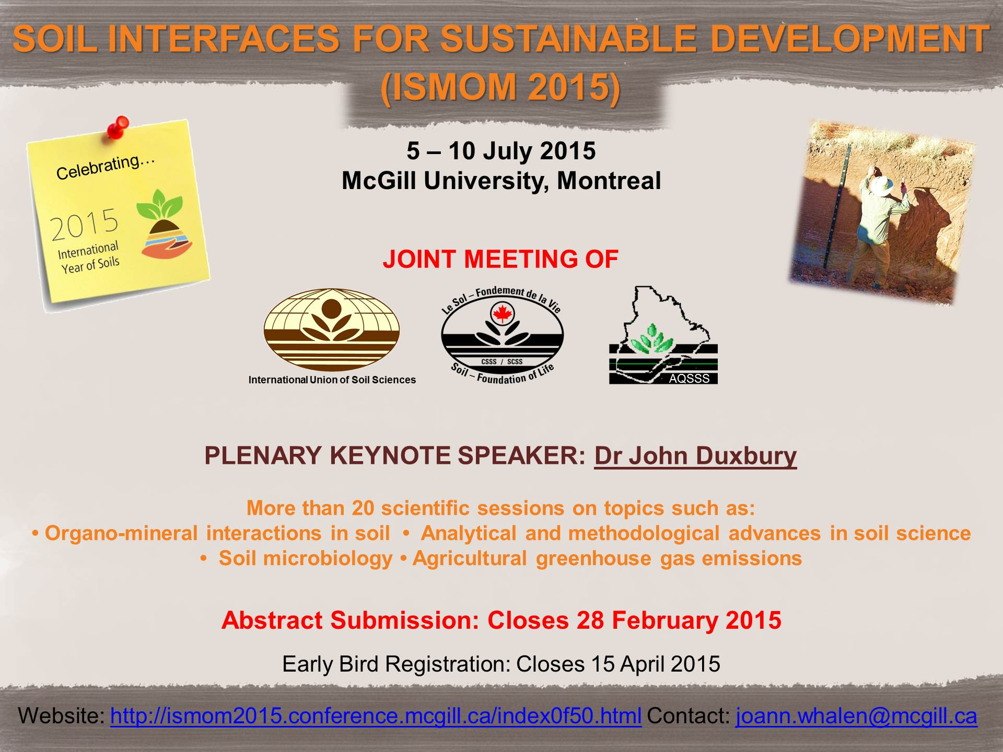

The CSSS annual meeting will be held in conjunction with the Association Québécoise de Spécialistes en Sciences du Sol(AQSSS) and the International Symposium of Interactions of Soil Minerals with Organic Components and Microorganisms (ISMOM), in Montreal July 5-10, 2015. A wide range of sessions have been planned. All conference attendees are welcome to submit abstracts to any session, regardless of the sponsoring society. Please note that attendees can submit up to three abstracts, only of which can be for an oral presentation (the rest will be posters). Abstract submissions will open shortly, and the deadline for abstract submissions will be Feb 28, 2015. The opening reception will be held on Sunday (July 5), and scientific sessions will be held on Monday, Tuesday, Wednesday and Friday. Field trips are planned for Thursday (July 9). A banquet will be held on Wednesday evening, which will include the CSSS awards. The banquet (and lunches each day) is included in the registration fee.

**STUDENTS PRESENTATION AWARDS:** Students competing for the Bentley (oral) or President (poster) awards are encouraged to submit to any session that is topically appropriate. However, student presentations may be moved to different sessions, to allow judging to be completed before the awards banquet on Wednesday. Students may submit up to three abstracts, as can all conference attendees. However, please note that only one presentation (oral OR poster) per student may be submitted for judging this year. Students submitting multiple abstracts will be asked to indicate which is to be judged. If this is not clear, none of the abstracts from that student will be judged.

**CSSS Year of the Soil 2015 Committee**

**Update, February 2, 2015**

**Submitted by Barbara Cade-Menun**

On the CSSS IYS 2015 committee are Barbara Cade-Menun (chair), Nathan Scaiff, Jacynthe Masse, Valerie Miller, Gerry Neilsen, Alison Murata and Anya Reid.

The roles of this committee are:

1. 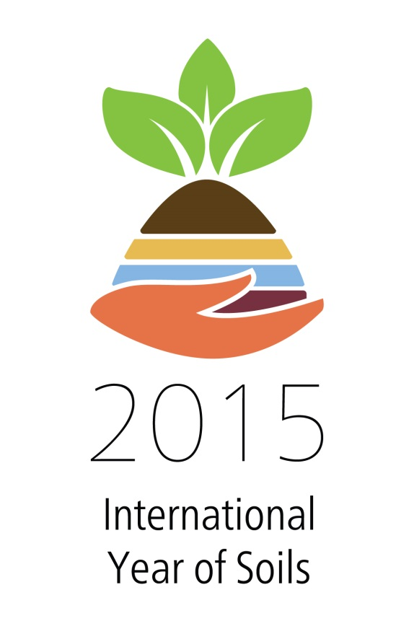To facilitate communication about the Year of the Soil Activities across Canada to other CSSS members and to the public. This will involve gathering information about the planned activities and then posting them to the CSSS website.
2. To plan an activity to celebrate the Year of the Soil during the CSSS/ISMOM/AQSSS meeting in Montreal in July.  The conference will run from Sunday July 5 to Friday July 10.  One suggestion that seems popular is to show a soils-related movie one evening and then have a panel discussion about soils. This would be a public event in a theatre on McGill’s downtown campus.  Suggested movies have been the Symphony of the Soil and Dirt the Movie.  Dirt the Movie seems the more popular choice. But there may be other films, etc., that we could show; suggestions are welcome. Ideally it will be in English or French with French or English subtitles.
3. To prepare a commemorative 2016 calendar.  We would like to give a copy to CSSS members, plus have some for sale.  It would be great if we could have them for sale at the conference in July, but we don’t want to sacrifice quality and do a rushed job.  If you have any high resolution soil-themed pictures that we can include in the calendar, please let us know.
4. The last suggestion is to put together a media release to a) tell everyone that it is the Year of the Soil; b) promote our website as a source of information about activities across Canada; c) let people know that if they want speakers for events we can put them in contact with soils experts.

If anyone has any events they would like to have listed, any photos for the calendar, or any other suggestions, please contact Barbara at [barbara.cade-menun@agr.gc.ca](mailto:barbara.cade-menun@agr.gc.ca). And new committee members are very welcome.

**2015 CALL FOR CSSS AWARD NOMINATIONS**

**Submitted by Maja Krzic, President Elect**

***FELLOW, HONORARY MEMBERSHIP, SOIL SCIENCE FOR SOCIETY AWARDS***

We all know someone who has made a significant contribution to Canadian soil science. The CSSS Fellow, Honorary Membership, and Soil Science for Society Awards represent your opportunity to make sure that this contribution is recognized. You need to nominate an outstanding colleague for one of these Awards in order for them to be eligible. The process is not complicated and the information needed is described on the CSSS website at [www.csss.ca/index.php/awards](http://www.csss.ca/index.php/awards). Take the time to submit an Award nomination for a deserving colleague before the deadline of **April 8, 2015.**

**CSSS Fellow Award**

This Fellow Award is bestowed upon CSSS members with a distinguished record of accomplishment in soil science and service to CSSS.

**CSSS Honorary Membership Award**

This Award honours non-members who have rendered valuable or special service to soil science.

**CSSS Soil Science for Society Award**

This Award is open to members or non-members who have made a significant commitment toward promoting soil science to the general public. The Award winner receives a plaque or certificate recognizing their contribution.

Please go to [www.csss.ca/index.php/awards](http://www.csss.ca/index.php/awards) for more details on the nomination process for CSSS Fellow, Honorary Membership, or Soil Science for Society Awards. All nominations must be submitted via e-mail (Word or pdf attachments) to Maja Krzic ([maja.krzic@ubc.ca](mailto:maja.krzic@ubc.ca)), Chair, CSSS Awards Committee by **April 8, 2015.**

***STUDENT AWARDS***

There are a number of Awards aimed at promoting student participation in CSSS.

**CSSS Student Travel Award**

This Award was established in 1991 to encourage student attendance at the CSSS Annual Meetings and is available to any graduate student CSSS member. The Student Travel Award is $600 with a maximum of 12 awarded annually. Our 2015 annual meeting will be held jointly with the Commission 2.5 of the International Union of Soil Science and Association Québécoise des Spécialistes en Sciences du Sol, July 5-10, 2015 in Montreal, Quebec (see article elsewhere in this newsletter).

Go to [www.csss.ca/index.php/awards](http://www.csss.ca/index.php/awards) for more details on the Student Travel Award and to download the application form. All applications must be submitted as e-mail attachments to Maja Krzic at [maja.krzic@ubc.ca](mailto:maja.krzic@ubc.ca) ([www.csss.ca/index.php/awards](http://www.csss.ca/index.php/awards)), Chair, CSSS Awards Committee by **April 8, 2015.**

**CSSS Student Presentation Awards**

1. The ***C.F. Bentley Award*** was initiated in 1983 to encourage and recognize excellence in oral presentations by students at the CSSS Annual Meetings. The Award honours [Dr. Fred Bentley](http://en.wikipedia.org/wiki/C._Fred_Bentley) who was CSSS President in 1956-57 and inducted as a CSSS Fellow in 1973. The C.F. Bentley Award winner receives $500, the first runner-up $300, and the second runner-up $200.
2. The ***President’s Award*** was established in 1992 to foster excellence in student poster presentations as a means of disseminating research results at the CSSS Annual Meetings. The President’s Award winner receives $500, the first runner-up $300, and the second runner-up $200.

When submitting an abstract for the CSSS Annual Meetings, graduate students should indicate that they wish to be considered for a Student Presentation Award. Note: this year students may submit only one presentation (either poster OR oral) for a competition award.

**CSSS Undergraduate Book Award**

This Award recognizes students at Canadian universities who demonstrate excellence in Soil Science at the undergraduate level. Award winners receive a copy of [Soil Sampling and Methods of Analysis](http://www.crcpress.com/product/isbn/9780849335860) (2nd Edition), published jointly by CSSS and CRC Press in 2008. Candidates are nominated by their University department.

**2014 CANADIAN SOCIETY OF SOIL SCIENCE AWARDS**

CGU/CSSS/CIG Joint Annual Meeting, Banff, Alberta, May 4-7, 2014

**Submitted by Frank Larney, CSSS Conference Chair, 2014**

The 2014 Joint Meeting of CGU and CSSS was held on May 4-7 at the Banff Park Lodge, Banff, AB. The scientific theme was *ꞌAdvances in Geophysical & Soil Sciencesꞌ*.

**Student Presentation Awards**

A total of 40 students competed for the Bentley Award for best oral presentation, and 23 students competed for the President’s Award for best student poster presentation; of these, two students competed for both the Bentley and President’s awards.

Congratulations to our 2014 winners of the Bentley Award:

*Amanda Guy*, of the University of Saskatchewan (first place)

*Jacynthe Masse*, of the University of British Columbia (second place)

*Adrianna Navarro-Borrell*, of the University of Saskatchewan, and *Gladys Oka*, of the University of British Columbia (who tied for third place)

|  |  |
| --- | --- |
| C:\Users\rheck\Desktop\RE student award pics\Bently Award Winner Amanda Guy.jpg  Barbara Cade-Menun & Amanda Guy (Bentley Award Winner) | http://csss.ca/wp-content/plugins/wp_roksprocket/cache/7cb1db38624d4f644f704a6a67636c03_300_0.jpg  (left to right) Adrianna Navarro-Borrell, Barbara Cade-Menun, Jacynthe Masse, Gladys Oka, Amanda Guy, David Burton |

Congratulations also to our 2014 winners of the President’s Award (coincidentally, all studying at the University of Saskatchewan):

*Xiaoue Wang* (first place)

*Chuckwudi Amadi* (second place)

*Mark Sigouin* (third place)

|  |  |
| --- | --- |
| C:\Users\rheck\Desktop\RE student award pics\President's Award winner Xiaoyue Wang.jpg  Xiaoyue Wang (President’s Award Winner) Barbara Cade-Menun | http://csss.ca/wp-content/plugins/wp_roksprocket/cache/8d8e176f24be991989df7036088c0c28_300_0.jpg  (left to right) Barbara Cade-Menun, Chuckwudi Amadi, Xiaoyue Wang, David Burton |

**Student Travel Awards**

Twenty-four applicants were received for 2014 CSSS Student Travel Award; of these 12 students were awarded $600 each. Congratulations to:

*Katelyn Congreves* (University of Guelph)

*Gurbir Singh Dhillon* (University of Saskatchewan)

*Adam Gorgolewski* (University of Toronto)

*Darrell Hoffman* (University of British Columbia)

*Ghulam Murtaza Jamro* (University of Alberta)

*Zhichao Jiao* (University of Alberta)

*Kirsten Kilde* (University of Northern British Columbia)

*Min Li* (University of Saskatchewan)

*Kristopher Novak* (University of Saskatchewan)

*Genevieve Noyce* (University of Toronto)

*E. RoTimi Ojo* (University of Manitoba)

*Kokulan Vivekananthan* (University of Manitoba)

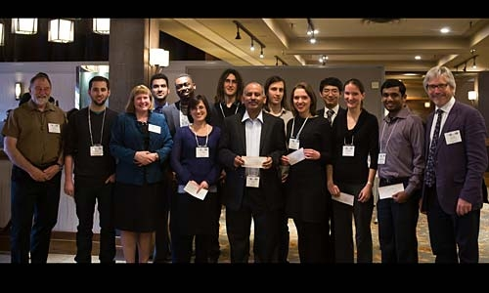

**Student Book Awards**

The recipients of the 2014 CSSS Student Book Award, recognizing excellence in Soil Science at the undergraduate level, were (each received a copy of *Soil Sampling and Methods of Analysis 2nd Ed*, published jointly by CSSS and CRC Press in 2007):

*Ophélie Boulanger* (McGill University)

*Jolene Godard* (University of Manitoba)

*Dana-Rose Keeler* (University of Saskatchewan)

*Jason Lussier* (University of British Columbia)

*Vincent Pelletier* (Université Laval)

*Joanne Ranson* (University of Northern British Columbia)

*Luzianne Reid* (University of Toronto)

*Felicia Syer* (University of Guelph)

*Carolyn Wilson* (Dalhousie University)

*Zoey Zaposocki* (University of Alberta)

**CSSS Awards**

There were no nominations received for the CSSS Fellow Award, the Soil Science for Society Award, nor for a CSSS Honorary Membership Award.

**CANADIAN SOCIETY OF SOIL SCIENCE 2014 TREASURER’S REPORT FOR 2013**

**submitted by Kent Watson,**

to the CSSS Annual General Meeting, Banff, Alberta

May 5, 2014

**Financial Reports for 2013**

The CSSS 2013 income expense statement shows the society continues to be very healthy financially, mainly as a result of an unprecedented level of income from higher than anticipated revenue for our Wood Gundy Investment Accounts.

**CSSS Operating Funds Income and Expenses**

Total income in 2013 was much more than budgeted (Table 1) as a result of one unanticipated income source. The Wood Gundy Investments generated $18,677 in revenue, a slight increase over last year. Expenses in 2013 were close to budget publication (Table 1). The 2013 Winnipeg conference did not generate any revenue for the society in 2013. An unusual event occurred in 2013. The CSSS loaned the MSSS $10,000 as start-up costs for the Winnipeg conference (This is not unusual). This appears as “Conference Start up Loan under expenses. The $81,071 under Other Income was conference fees collected by the CSSS business Office. Conference fees collected $71,071 less the $10000 advance was paid to the MSSS. There was an additional $60.00 in other Operating expenses that brought the Operating Expenses total to $71.131.

**CSSS Balance Sheet for Trust and Operating Accounts**

Equity in the CSSS Trust Fund increased again in 2013 to its highest level since 2009. The trust fund increased in value from $334,877 from December 31, 2012 to $353,555 by December 31 2013, an increase of $18,677. A number of accounts became due during 2013 and the proceeds’ were placed into Mutual Funds. As of December 2013, the Trust fund held approximately 39% in income investments, approximately 17% of its assets in equity funds and approximately 44% in mutual funds. The majority of the Trust Fund is held as a series of different types of bonds with interest rates ranging between 4.16% and 5.53% and staggered maturity dates from September 2011 through December 2020.

The combination of funds in the CSSS savings account and term deposits provides a healthy buffer in case of large and unanticipated CSSS expenses. The CSSS remains financially healthy. (Note that the Wood Gundy Fund is a trust fund and is to be held as such into the future. This fund generates revenue that is used, when need be, to offset the student awards).

**Budget Proposed for 2015**

There are no major changes anticipated for the 2015 financial year (Table 1). The term deposits in the operating accounts will increase interest earnings. Membership revenue is expected to remain at levels similar to 2013. Potential conference revenues from the 2014 meeting in Alberta are difficult to forecast and has been estimated at $2000 to balance the proposed budget.

Currently, there are no special projects anticipated for the Trust Fund. However, CSSS certainly is in a financial position to fund a special project if an appropriate initiative is identified.

The small surplus forecast for 2015 will not create any financial problems for CSSS.

Table 1 also presents the historical Balance Sheets for 2011, 2012 and 2013. Table 2 is the Balance Sheet from Jan 1, 2013 to Dec 31, 2013. Table 3 is the Income Statement from Jan 1, 2013 to Dec 31, 2013.

Table 1 Income and Expenses for 2013 Budget and Actual and Proposed 2015 Budget



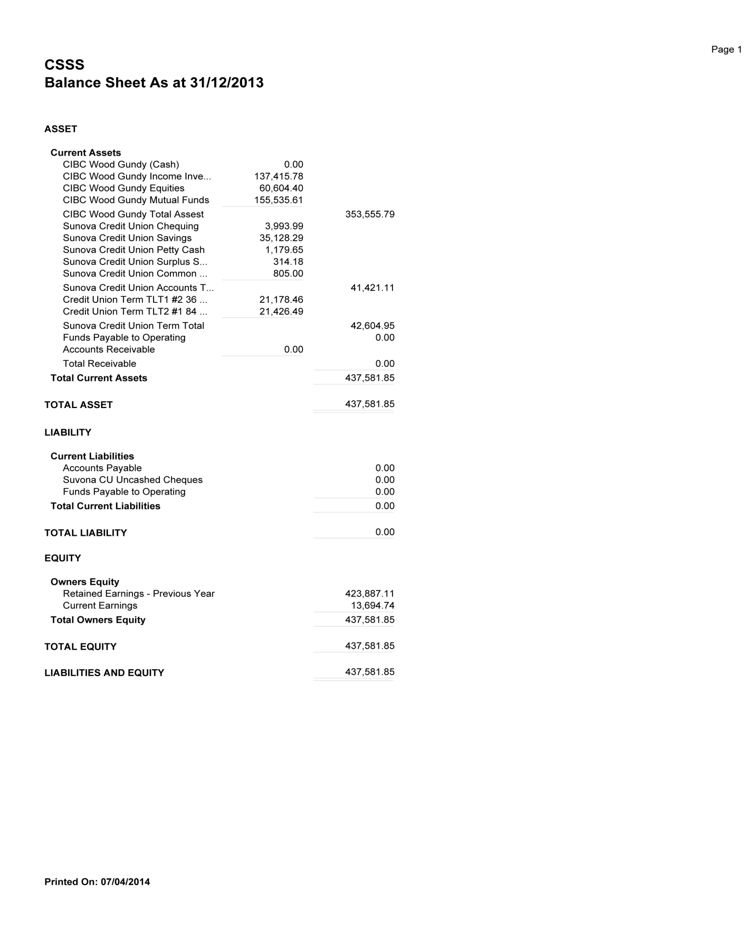Table 2 Balance Sheet Jan 1 to Dec 31, 2013

Table 3 Income Statement Jan 1 to Dec 31, 2013

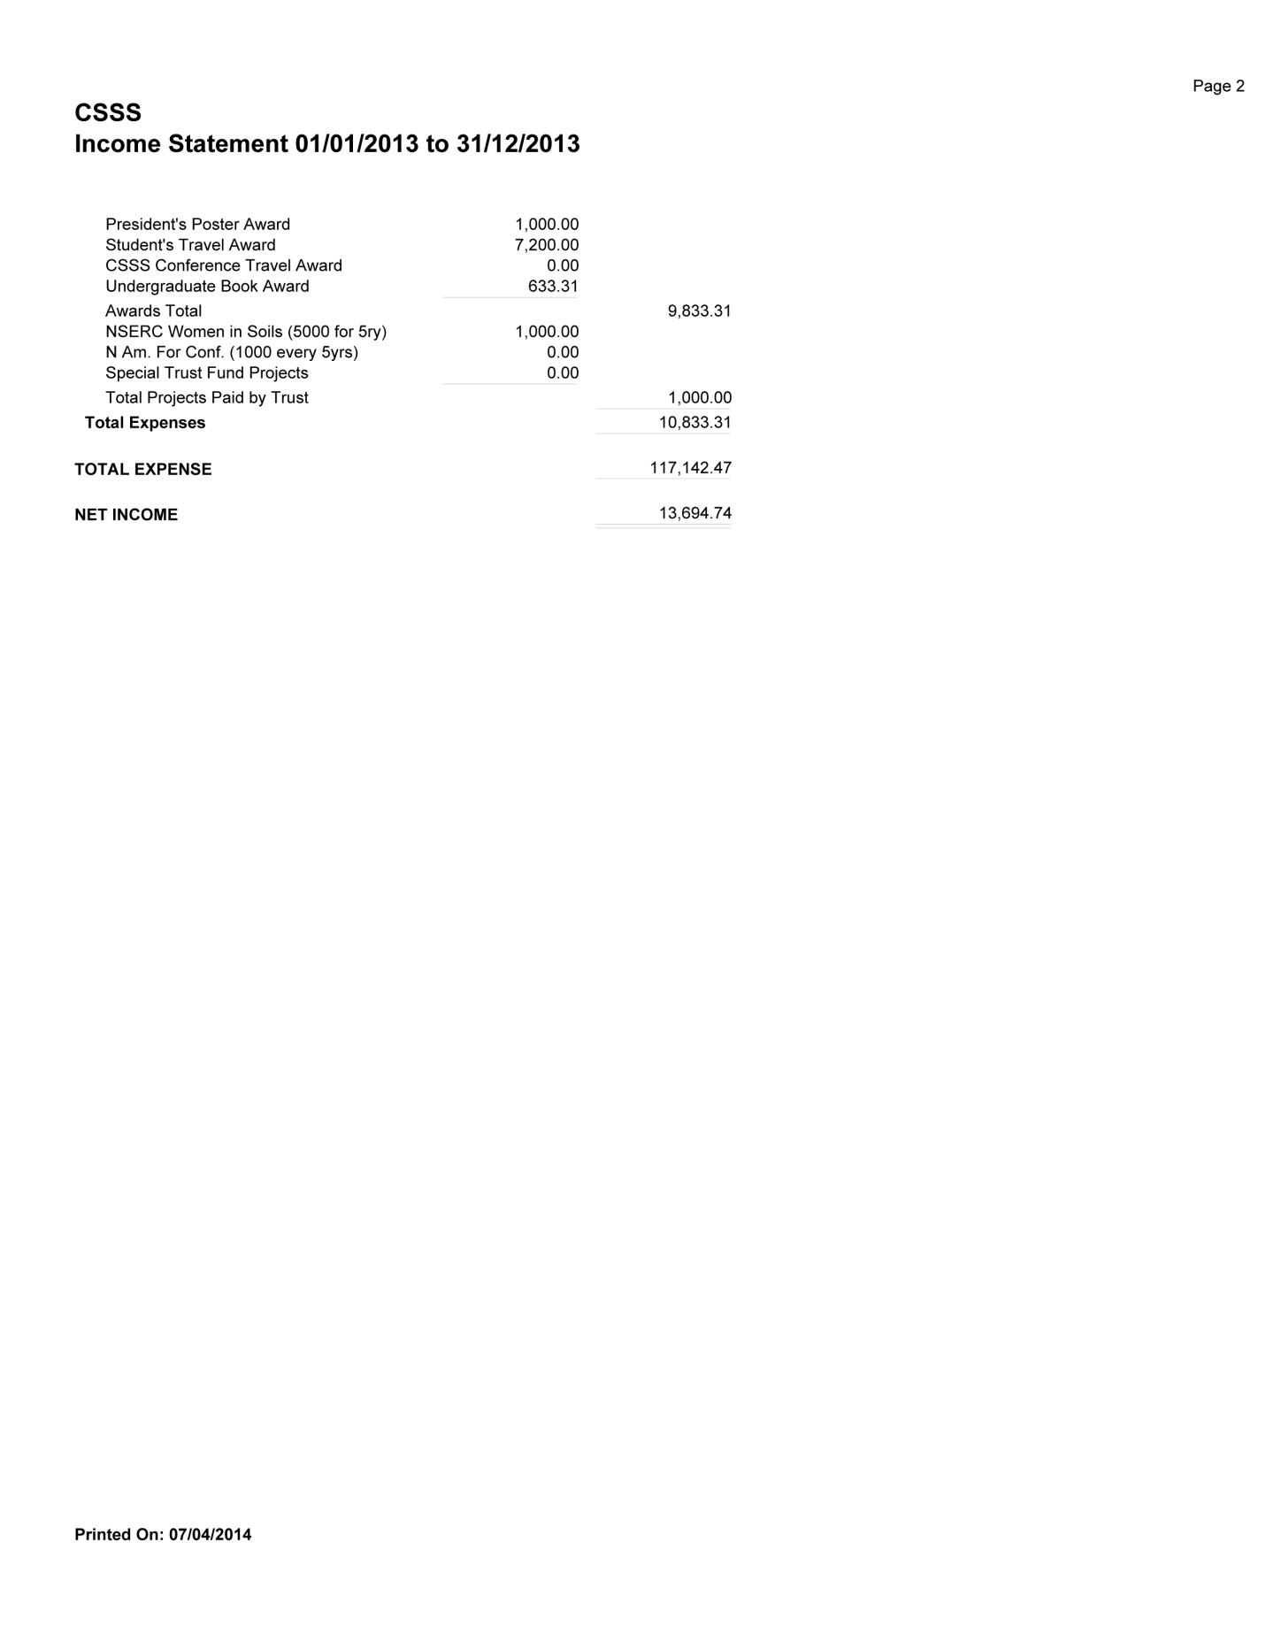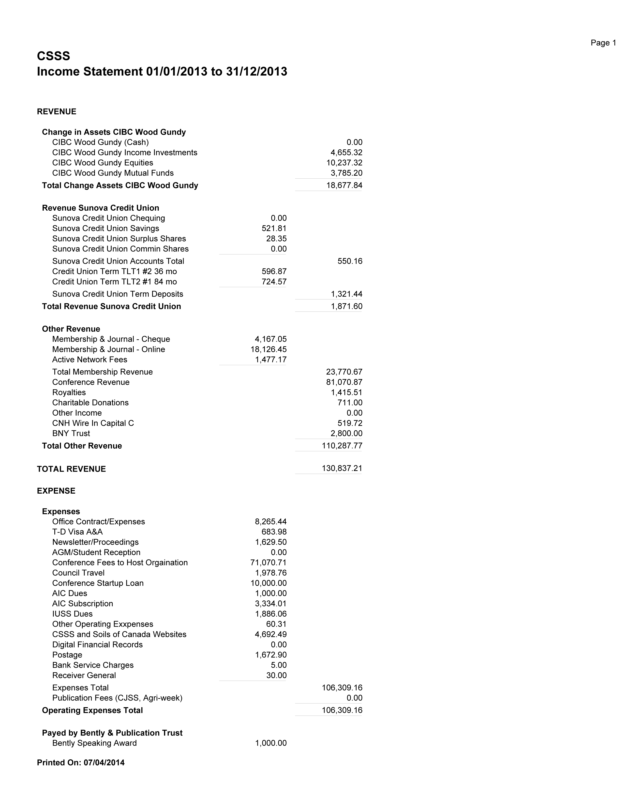

**IN MEMORIAM**

Soil Science lost one of its Greats

**submitted by Dr. Pieter Groenevelt (Guelph, Ontario)**



**Dave Elrick**

**A tribute by one of his colleagues, Brent Clothier (Palmerston, New Zealand)**

It was with a heavy heart that I opened an email from Mei-fei Elrick in late August. The subject line said it all. Dave Elrick had died. The soils’ world had lost a brilliant scientist. I had lost a personal and family friend, colleague and mentor, and a bloody competitive running mate. At the recent Soil Science Society of America meetings in Tampa earlier this month, when his death was recorded at the Soil Physics Division meeting, the comments were that Dave was a gentleman. And of course we all knew that he was a scholar too. I worked with Dave during 1984 in Guelph, and then ‘off-and-on’ thereafter in New Zealand and France. It was a magic time for me in 1984 in Canada, as under Dave’s leadership the Guelph permeameter was taking shape. There, with Dan Reynolds, we argued incessantly about the ‘correct’ theoretical solutions for the steady flow of ponded water into unsaturated soil from a cylindrical hole. Then we’d calm down and go out for a frigid run in bracing Canadian conditions. No excuses, said Dave, for the weather. It’s Canada, just get out there and run. That’s Dave. Then there’s family. Dave’s love of soil physics was only exceeded by his love of family – especially his, and then those of his friends. Vale Dave. We miss you. I have appended the (modified slightly by me) obituary for Dave from the Guelph newspaper:

**ELRICK, David** 81, of Guelph, beloved husband, father, and grandfather, passed away early morning August 20, 2013 during heart surgery for an aortic dissection.

David, was born September 6, 1931 in Toronto, to the late Emerson and Emma Elrick; brother of Doug (deceased). David was married in 1958 to Mei-fei (nee Rosholt) in Rosholt, Wisconsin. David's undergraduate degree was from the Ontario Agricultural College and the University of Toronto in 1953, and his PhD was from the University of Wisconsin, Madison in 1957 with Wilford Gardner and Champ Tanner. David then began work as an Assistant Professor in Physics in 1957 at the OAC-University of Guelph where he looked younger than most of his students. In 1960, he moved to Canberra, Australia where he worked at CSIRO. In 1962, he returned to Guelph where he worked in the Soil Science Department as a teacher and researcher until he retired at age 65.

After retirement, he held positions at the Arid Land Research Centre in Tottori, Japan; Leuven University in Belgium; and Laval University in Quebec. In the early 1980's he co-developed a field instrument; the Guelph Permeameter. David received Fellowships in the Canadian Society of Soil Science, the Soil Science Society of America and was made a University Professor Emeritus. Survived by his wife, Mei-fei, sons Stephen (Debbie deceased), James (Cristine), Pierre (Elaine), and five grandchildren: Ayla, Nicholas, Meghan, Jade, and Kellie. Pre-deceased by his much loved son, Michael (Heather).

**A tribute by one of his Graduate Students, Dave Fallow (Georgetown, Ontario)**

Dave Elrick greatly enjoyed and was highly skilled in the physics and the mathematics involved in creating solutions to soil physics problems. From the partial derivative and the definition of the initial and boundary conditions, to the mathematics used to find a solution, he found great pleasure in every step and great accomplishment in the determination of the solution. His appreciation of the physics and mathematics was for the process and the innovation of the effort, extending to the admiration of the work and equations developed by others. When reviewing work by other people, he often referred to the author as a, “smart guy”, when noting the ingenuity of the solution. It is this great skill and regard for the physics and mathematics that Dave brought to every collaboration, from his many grad students to his abundant and well-respected international work. Over his noteworthy career he published more than 80 papers in refereed journals, 35 non-refereed papers and reports, contributed to 15 chapters in books and participated in the editing of three books, emphasizing not only his proficiency, but the great enjoyment he found in his profession.

Dave’s longest running collaboration was with Norbert Baumgartner. It was an ideal combination of Dave’s physics and mathematics expertise, and Norbert’s technical abilities that resulted in the development and testing of many solutions to various Soil Physics processes and other soil related problems. His most well-known collaboration was with Norbert and Dan Reynolds during the development of the Guelph Permeameter, the Guelph Pressure Infitrometer, and the Guelph Tension Infiltrometer. This work resulted in the Guelph Permeameter being awarded as one of the top 50 outstanding innovations in product or systems technology for 1986-1987, and the licensing of that technology to the Soilmoisture Equipment Corporation of Santa Barbara, California. As of Dave’s passing, over 1500 Guelph Permeameters had been sold worldwide

**PUBLICATIONS**

Soil and Environmental Science Dictionary, edited by Ed Gregorich, Larry Turchenek, Martin Carter and Denis Angers. CRC Press ((Cat #3115) – 50% discount for CSSS members extended (use promo code **327FC).**

**UPCOMING CONFERENCES**

* In celebration of 2015 as the International Year of Soil, the CSSS will hold out annial meeting **Soil Interfaces for Sustainable Sevelopment** **(ISMOM 2015)** jointly with the International Union of Soil Sciences and the Association québécoise de spécialistes en sciences du sol July 5-10th in Montreal: <http://ismom2015.conference.mcgill.ca/>
* European Geosciences Union meeting titled “Bringing Soil Science to the Field” Vienna, Austria. April 12-17, 2015. <http://www.egu2015.eu/home.html>
* Joint with the American Geopyisical Union, the Canadian Geophysical Union, Geological Association of Canada, and the Mineralogical Association of Canada will host their annual meeting in Montreal May 3-7: <http://ja.agu.org/2015/>
* The Soil Science Society of America, American Society of Agronomy, Crop Science Society of America, and Entomologogical Society of America will hold a joint annual meeting **Synergy in Science** November 15-18 in Minneapolis, MN, USA <https://www.acsmeetings.org/2015-data-stewardship>
* Global Soil Security Symposium. Texas A&M University, College Station, TX. May 19-21, 2015. <https://www.soils.org/meetings/global-soil-security>
* Earth Educators' Rendezvous, University of Colorado, Boulder. July 13-17, 2015. <http://serc.carleton.edu/earth_rendezvous/2015/index.html>
* They Canadian Society of Agronomy along with 12 other Canadian and US Societies will hold their annual meeting **Botony 2015.** July 25-29 in Edmonton <http://www.botanyconference.org/>
* **70th Soil and Water Conservation Society International Annual Conference “**Coming Home to Conservation: Putting Science into Practice” July 26-29, 2015, Greensboro, NC. <http://www.swcs.org/en/conferences/2015_annual_conference/>

CSSS-Business Office